# Handbook for recognition generator of Bober competition

## How to read this handbook

This handbook is written in chapters. Each chapter has quite descriptive name of the content written inside. That's why if you find content trivial or if you don't need to know it, you can easily pass to the next chapter.

## Who is this handbook for?

This handbook is written for anyone who would like to use recognition generator of Bober competition. It can help you if you bump into troubles while using this application.

## Requirements

The application was tested on Windows 7. It might work on older Windows systems though it doesn't on Windows 8 and later OS. It also doesn't work on UNIX based systems. You also need to have installed Java.

## Application set up

### Getting application from web

First thing you need to do during set up is load whole application from web. You will get lots of files. We strongly suggest that you don't delete any file because it might lead to unwanted errors. At this point if you run BoberGenPriznanj.jar you should get a bunch of generated test recognitions in folder »Priznanja«. However if generation fails it probably means that your software doesn't fit requirements or you changed the hierarchy of files (Figure 1).

Downloaded folder contains three files which are necessary for running application, »BoberGenPriznanj.jar«, »csv-pdf_1_42.jar« and »nastavitve.ini«, which is used for setting up configurations. It also contains two folders: »PodatkiCSV«, which consists of the data which will be inserted later on, and »PodatkiPDF«, which contains templates of files which will be generated.

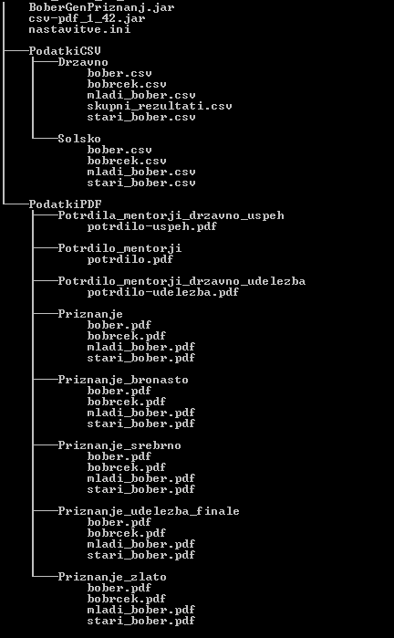

Figure : Scheme of obligatory files inside downloaded folder

You've just generated a bunch of test recognitions. Now let us generate the ones you want.

### Changing layout

At first you'll probably want to change layouts of recognitions. To do that you should use a program that supports vector graphics, like Inkscape, Adobe Illustrator etc. You need to open a ».svg« file you want to change, change it and then save it as ».pdf« file, with name that replaces an existing one. While doing this be careful that you don't change locations of the lines, where names of the competitors, school and rate of success should be, because the writings inserted afterwards use static locations. To know precisely which parts should not be changed, we suggest you take a look at template examples and look for dynamic content (personal names, school names notifications etc.).

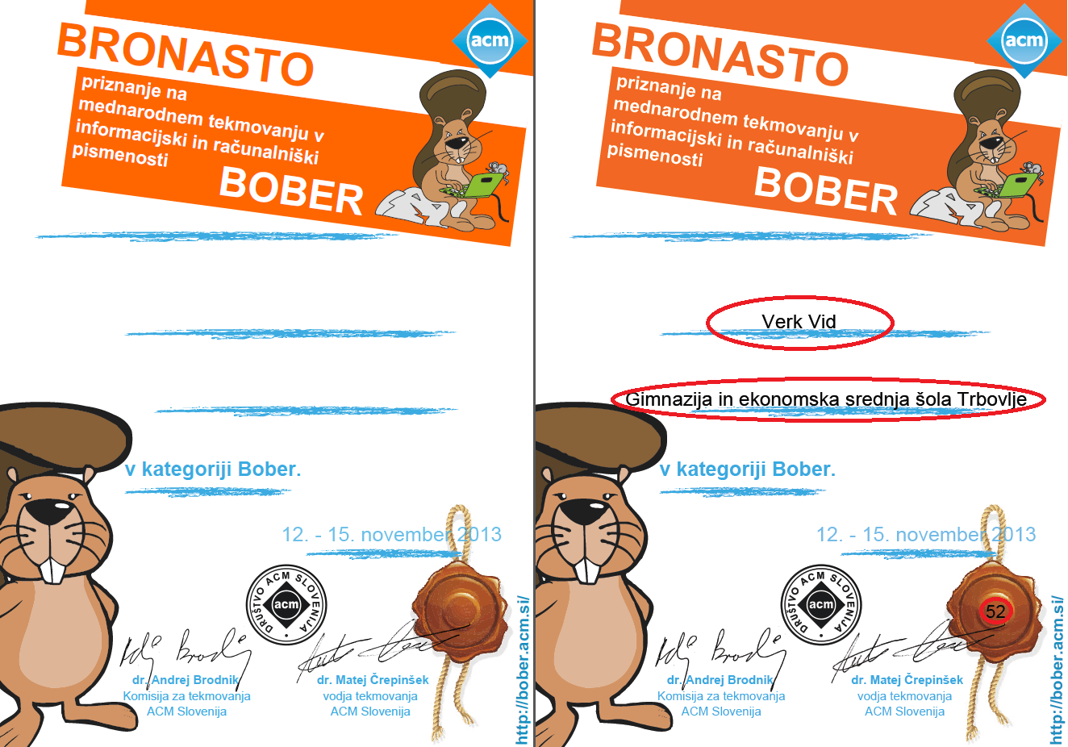

Figure : Example of layout (left) and generated recognition (right) of competitor

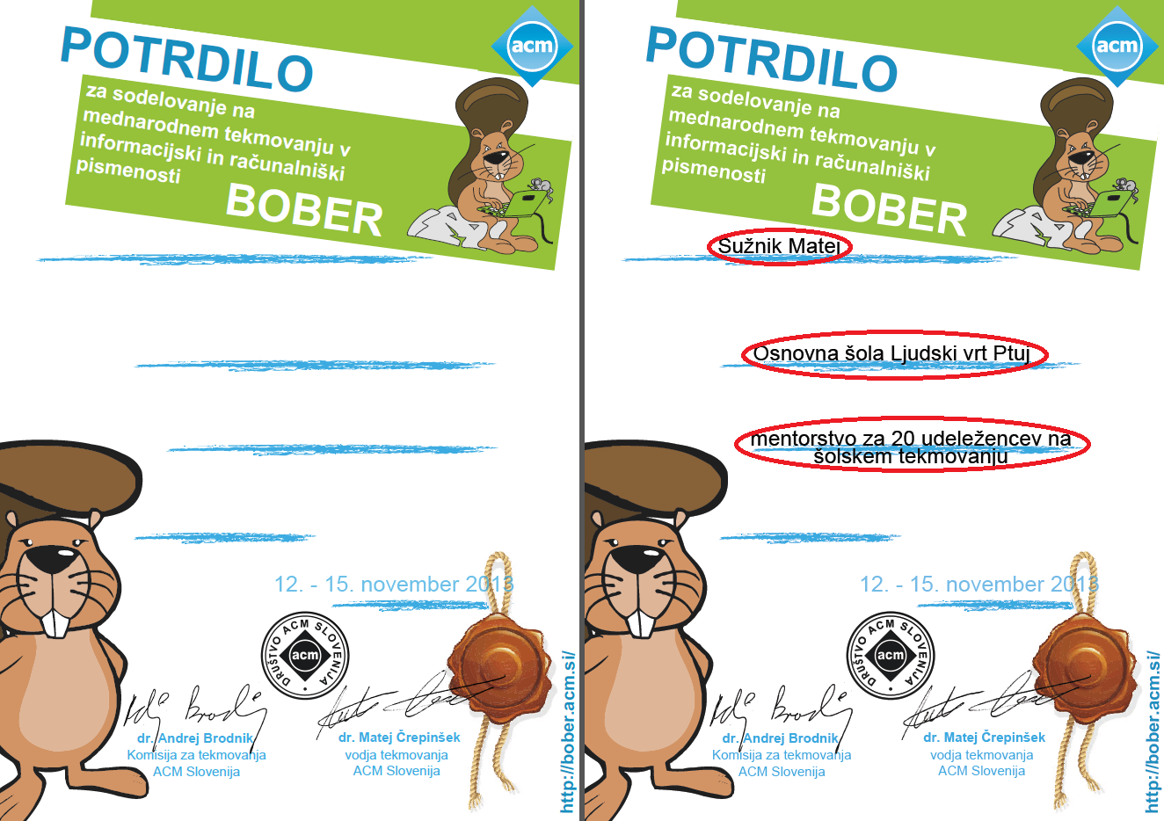

Figure : Example of layout (left) and generated recognition (right) of mentor

### Inserting custom dynamic data

It's time for custom data insertion. This application captures data from ».csv« files. You can get these files from Bober website. At these point again you have to be extremely careful not to change any data names. The rules here are equal to the ones, related with ».pdf« files in phase of changing layouts, meaning that you should get your data into application by replacing template files with new ones.

### Changing settings

In case you don't want to have all recognitions generated, you can manage that by changing »navodila.ini« file. Open it with text editor (like notepad) and set which type of recognitions you want to generate. You can do this by writing 1 for setting it on or 0 to disable generation for specified type of recognitions (Figure 4).

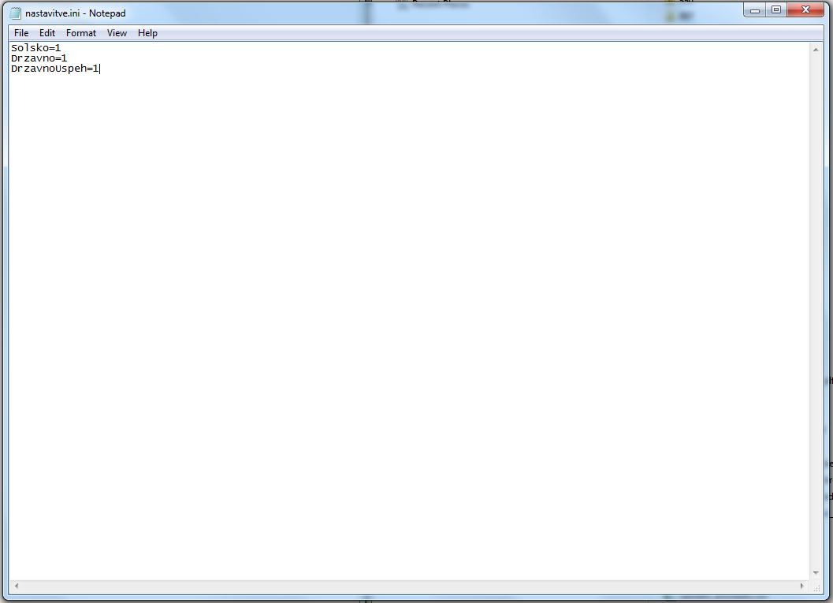

Figure 4: Changing of "nastavitve.ini"

Now you're ready to start a generator.

## Generating results

### Results generation

The most important part of this application is setting up the document. Thus this part – actual generation of recognitions is quite simple. You only need to run »BoberGenPriznanj.jar« by double clicking on it. If you set the configuration correctly you should get a newly created folder »Priznanja« with all generated recognitions. Be patient, because generation of results might take some time. Generation process is finished when folder »Priznanja« stops changing.

### Results hierarchy

There are two main types of recognitions currently supported by our recognition generator. First is state stage (in test data marked as »Drzavno«) and school stage (»Solsko«). The difference is that on state stage there is only one competition per year and it happens on predetermined date and hour. That’s why all the recognitions for the specific branch of competition are stored in single ».pdf« files. School stage competitions on the other hand happen once a year per school and are independent to other school stage competitions. That means that recognitions must be separated by schools somehow. For us it’s easier to separate them by mentors which are responsible for competition on specific school. That’s why each mentor gets folder, equal to his or her ID, where all the recognitions of competitors under his guidance are. For easier guidance there are also »seznam_bronasto.csv« and »seznam_zlato-srebrno.csv« files generated, which contains names of mentors and their ID-s.

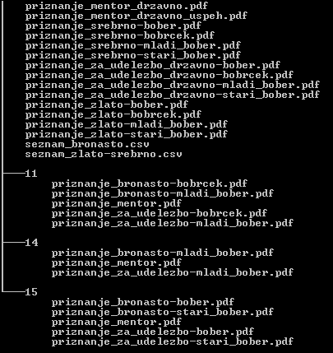

Figure 5: Finnal hierarchy of files

Luka Krsnik